BLANKET CERTIFICATATION:
January 1, 2026 to December 31, 2026

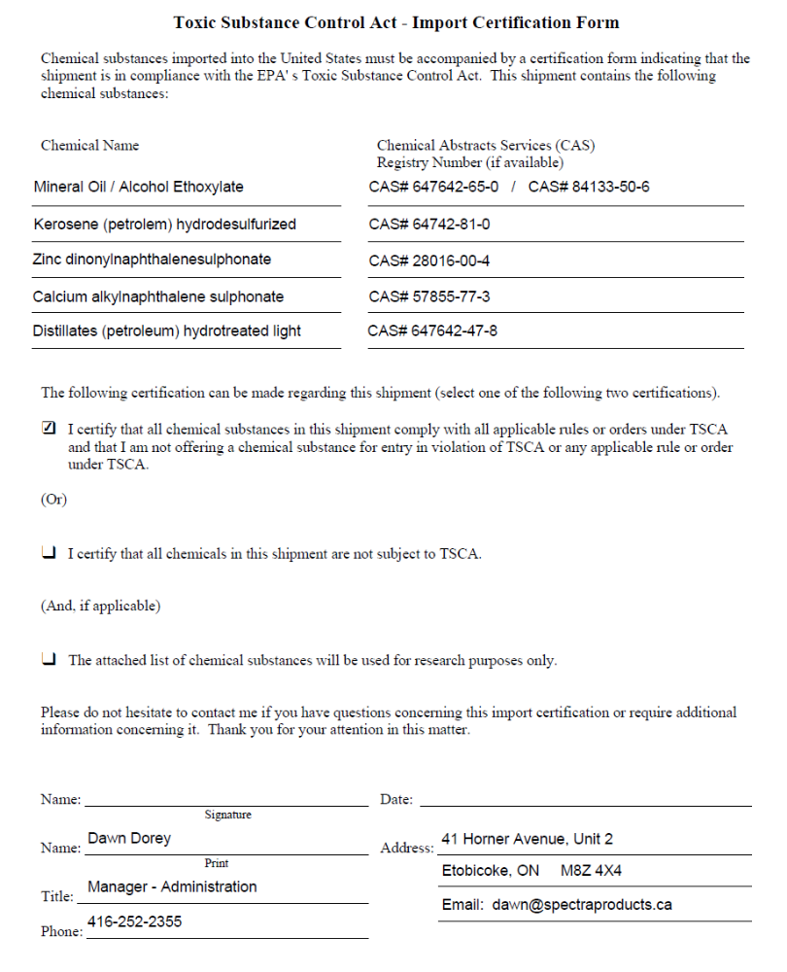
Proprietary additives
185857-36-7
Alcohols, C12-14- secondary, ethoxylated

Kerosene (petroleum) hydrodesulfurized

Alkanes, C10-13 - branched and linear

Lubricating oils (petroleum), C-20-50,Hydrotreated neutral oil-based

CAS# 64742-65-0 / CAS# 84133-50-6
8042-47-5
84133-50-6

